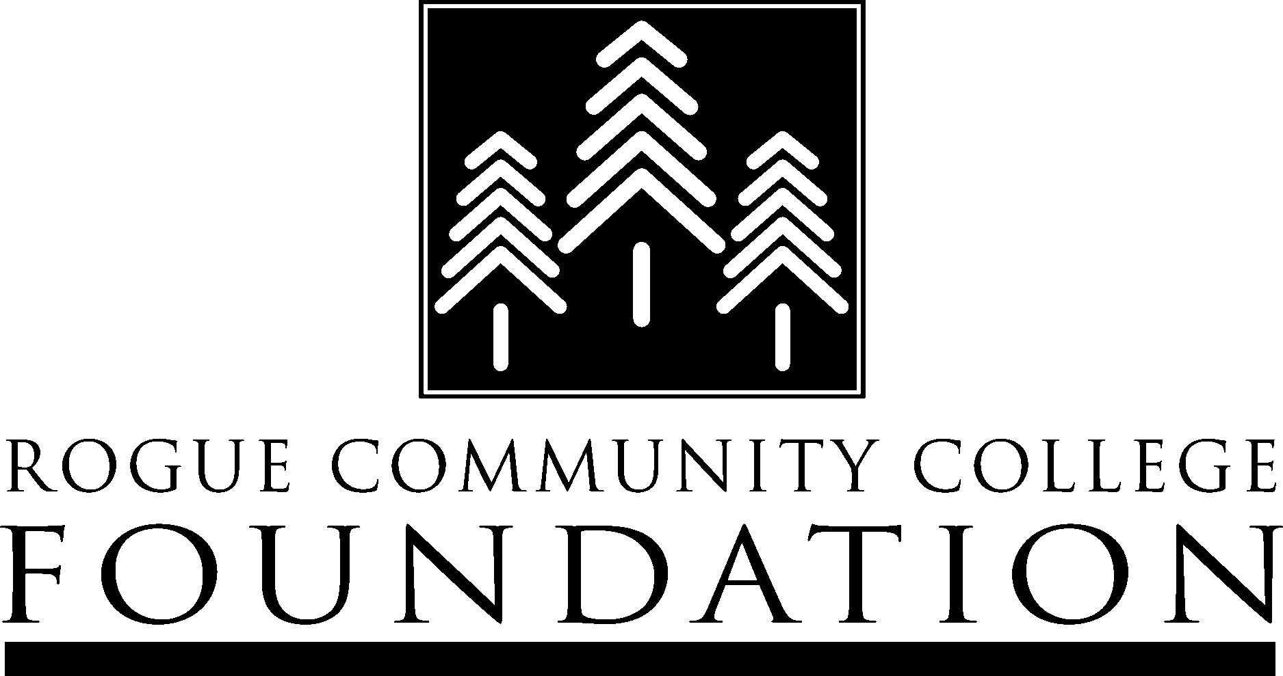
RCC Bequest
RCC Foundation
3345 Redwood Highway
Grants Pass, OR 97527
www.rccfoundation.org
“I give, devise and bequeath to Rogue Community College Foundation, a nonprofit organization as described in section 501c3 of the Internal Revenue Code, to benefit American Association of University Women (AAUW) Ashland Endowed Scholarship Fund a donation of the sum of $_______________ or of approximately ______percentage of the residual.
Rogue Community College Tax ID is #93-0777701.
A percentage bequest is a bequest of a certain percentage of your estate or of another asset
An example of a percentage bequest might be providing that, upon your death, your house be sold and that each of your four children receives one-fourth of the net proceeds.
A residual bequest is a bequest of all or a portion of the remainder or the residue of the estate after a specific and other bequests have been distributed. An example of this type of bequest might be providing that after all previous bequests have been satisfied everything that remains should be given to your charitable beneficiary.

Donor Signature _________________________
Name of Donor__________________________
Address of Donor________________________
City, State, Zip___________________________
Date __________________________________

